MyCompany.com

Online Shopping Portal

**Operation Manual**

**Table of Content**

i. Introduction

1. Admin

2. Internal User

3. Vendor

4. Customer

**Introduction**

Customer requires selling several **prime branded products** on line using myCompany.com website. He is interested selling branded watches, Ties, Shoes, Pants and Shirts. He has several branded customers, upload their products on line and myCompany.com hosts their products on their web site. MyCompany.com allows credit card and debit cards from all the banks except AMEX. Credit and Debit cards include VISA and MASTER CARDS. The financial part of myCompany.com will be outsourced to myFinance.com. Reports for every week, month, quarter and yearly are generated for the financial purposes.

1. Admin

The admin default password is “123”

To login click on login and enter admin username and password

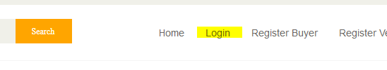

If successfully login you will direct to admin page